* Use case diagram: -
* Selling subsystem:

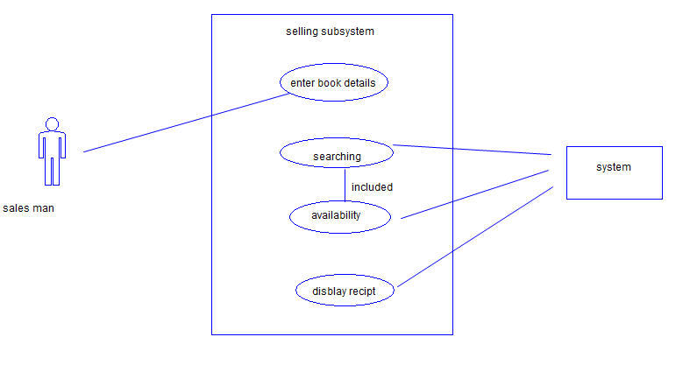

* Storage subsystem:

